Battle of Neighborhoods

Seattle, Washington

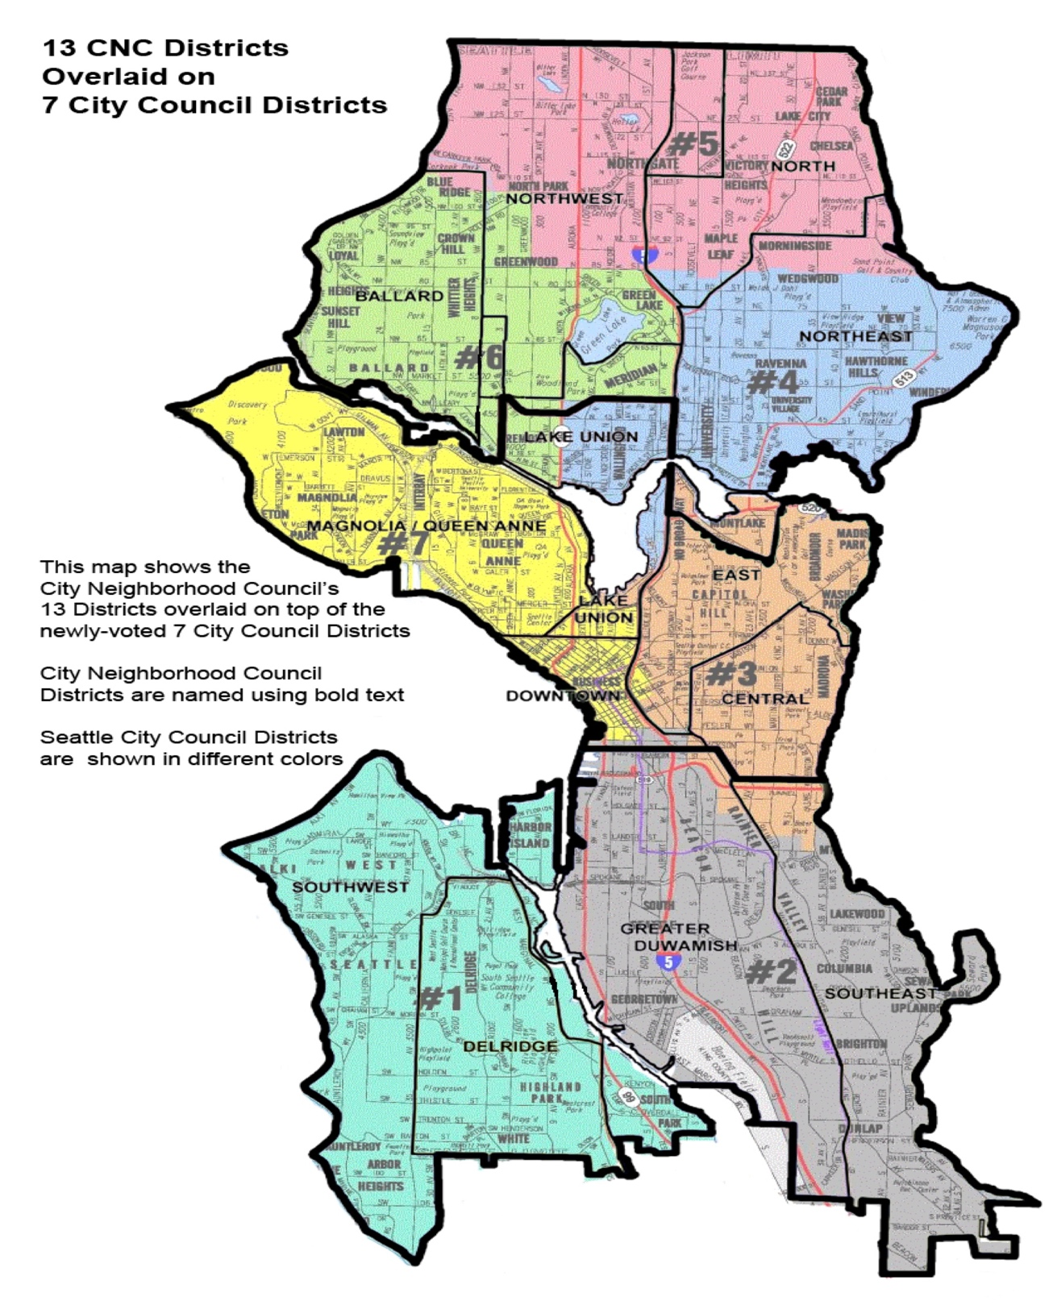

**Project Description:**

Usually people tend to explore the places before moving to a new country, state, city or place for their work or to start a new life and that involves so many factors including neighborhood analysis. That calls for a search algorithm that usually returns the requested features such as population rate, median house price, school ratings, crime rates, weather conditions, recreational facilities etc. It’d be nice to have a hassle-free application that could spit out an extensive analysis of all these features for a neighborhood or a comparative analysis between neighborhoods with just sending out the names of the neighborhoods

This Project takes this requirement as its main idea to help the stake holders to achieve the desired results, so as to help them spend their time and money in some other productive means rather keep them trapped in an infinite loop of extensive search engines.

This Project would help the stakeholders take a better decision on choosing the best neighborhood out of many neighborhoods to build/buy their houses in Seattle city based on the distribution of various facilities in and around that neighborhood. As an example, this project would compare 2 randomly picked neighborhoods and analyses the top 10 most common venues in each of those two neighborhoods based on the number of visits by people in each of those places. Also, this project uses K-mean clustering unsupervised machine learning algorithm to cluster the venues based on the place category such as restaurants, park, coffee shop, gym etc. This would give a better understanding of the similarities and dissimilarities between the two chosen neighborhoods to retrieve more insights and to conclude with ease which neighborhood wins over other.

------------------------------------Thank You---------------------------------------------